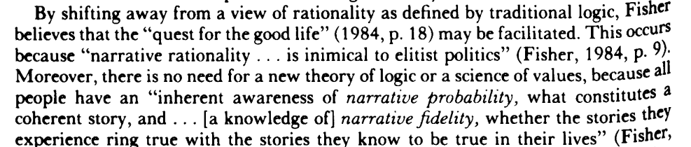

Narrative is so broadly defined that it loses its powers



